**F722 35A AIO Brushless Flight Controller**

4 reviews

Top of Form

Gyro

ICM42688

Version

V1 with BLHeli\_S ESC

V2 with BLHeli\_32 ESC

Quantity

Bottom of Form

Top of Form

Bottom of Form

F722 35A AIO Brushless Flight Controller is very reliable to meet your advanced FPV needs. Comes with an F722 chip this board provides a great performance capability and high processing speed, which brings pilots a stable and smooth flight. Featuring a 6-pin plug&play port, it can directly connect HD Digital VTX with NO soldering work. With the support of up to 6S input voltage, this FC pushes FPV racer to the max.

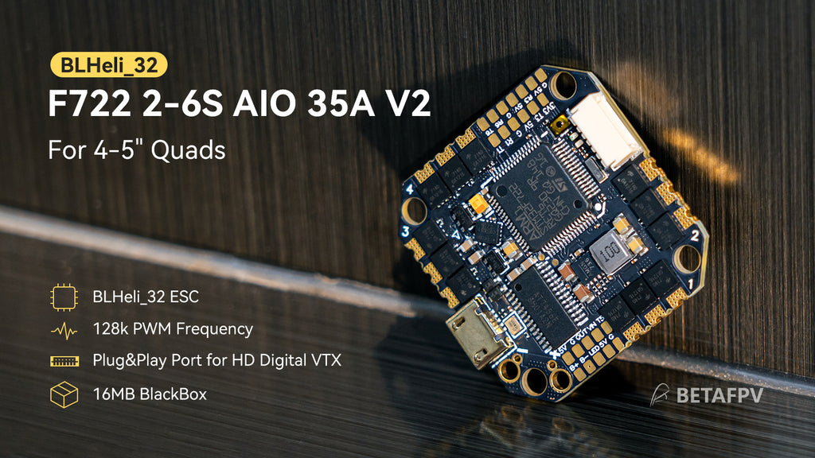

**Bullet Point**

* Built-in STM32F722RET6 CPU, F722 FC is more powerful than F4. It features a fast processing speed and stable performance, providing reliable and smooth flight for 4"-5" drones.
* F722 AIO 35A FC has specially added a 6-pin connector for HD Digital VTX, just plug & play, less solder work needed, perfect for the pilots who enjoy the HD Digital VTX system.
* 6 full UARTs are available on this board. With plenty of UARTS, Pilots could have more options for external parts like VTX, GPS, Receiver, and other components.
* It can handle 35A continuous current (40A burst), supports the 2-6S lipo battery, and gives the drone a more robust flight performance.
* With the 6S battery and this F722 35A AIO FC, the drone will break through the limit of the power of the toothpick drone, exploring more possibilities in 4-5'' drones.
* The new BLHeli\_32 ESC version is built-in a 16MB flash memory chip dedicated to Blackbox logging, which is an extremely powerful tool for tuning and troubleshooting an FPV drone. It has a faster processing speed and up to 128k PWM frequency, providing a more stable and smoother flight for pilots.

|  |  |  |
| --- | --- | --- |
|  | V2 with BLHeli\_32 ESC | V1 with BLHeli\_S ESC |
| PWM Frequency | 24k-128k | 24k-96k |
| ESC Firmware | BLHeli\_32.9, 32-bit | BLUEJAY V0.16, 8-bit |
| Blackbox | 16MB | Not included |
| Weight | 9.00g | 7.06g |
| Board Thickness | 1.6mm | 1.4mm |

**Specification of FC**

* Item: F722 35A AIO Brushless Flight Controller
* Weight: 7.06g(BLHeli\_S) / 9.00g (BLHeli\_32)
* CPU: STM32F722RET6
* Six-Axis: ICM42688
* Mounting hole size: 26mm\*26mm
* Firmware version: betaflight\_4.3.0\_STM32F7X2
* OSD: Built-in BetaFlight OSD (OSD chip: AT7456E)
* Support programmable LED like WS2812 etc
* Built-in current sensor
* Blackbox: 16MB (V2 with BLHeli\_32 ESC included)

**Specification of ESC**

* Signal support: PWM, Oneshot125, Oneshot42, Multishot, Dshot150, Dshot300, Dshot600
* Receiver: Support Frsky XM/XM+ Receiver/ Futaba Receiver/Flysky Receiver/DSMX Receiver/TBS Crossfire Receiver (requires external connection)
* Input voltage: 2S-6S Lipo
* Continuous current: 35A
* Peak current: 40A
* ESC firmware: BLUEJAY G\_H\_30\_48\_v0.16 (BLHeli\_S) / BETAFPV\_35A\_V2\_BLHeli\_32\_Multi\_32\_9 (BLHeli\_32)
* Indicators: Power indicator (Red) / FC indicator (Blue)
* Capacitance: CS|5\*10\*13mm|470μF|35V
* Connector: 80mm 14AWG silicone cable with XT60
* Recommended motors: 14XX series, 15XX series, 16XX series, 18XX series, 20XX series

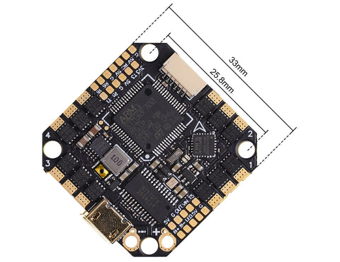

**BLHeli\_32 ESC Firmware**

The F722 35A AIO FC has two boards with different ESC versions for choice. The V2 board uses AT32F421G8U7 MCU, a 32-bit  ESC chip, with BLHeli\_32 ESC firmware. This firmware supports up to 128k PWM frequency, featuring faster processing speed and unlocking more functions for the flight.

|  |  |  |
| --- | --- | --- |
|  | BLHeli\_32 ESC | BLHeli\_S ESC |
| MCU | AT32F421G8U7 | EFM8BB21F16G-C |
| Firmware Version | BLHeli\_32.9, 32-bit | BLUEJAY V0.16, 8-bit |
| PWM Frequency | 24k-128k | 24k-96k |
| Bidirectional DSHOT | Support | Support |
| Signal Support | PWM, Oneshot125, Oneshot42, Multishot, Dshot150, Dshot300, Dshot600 | |

**Know More About ICM42688 Gyro**

The F722 FC ICM42688 version has the same solder pad and layout as BMI270 except for the gyro chip. Besides, you can also find the difference in Betaflight settings.

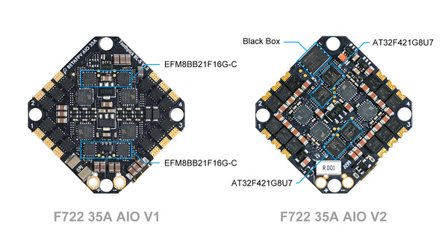

The ICM42688 gyro supports 8.00 kHz gyro update frequency compared with the BMI270 gyro which supports 3.20 kHz. When using a 6S battery, the ICM42688 gyro has a good performance.

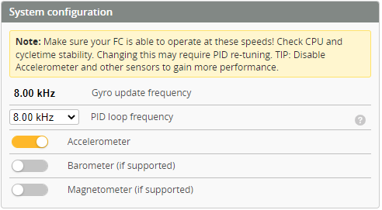

The degree between ICM42688 and BMI270 gyro is different. When configuring F722 FC ICM42688 version, the gyro degree should be set to CW270°.

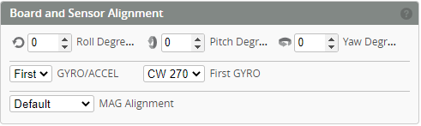

**Diagram for F722 35A AIO FC**

The below picture is the top front of the F722 35A AIO Brushless FC. (Both V1 and V2 boards have the same solder pad and connector ports.)

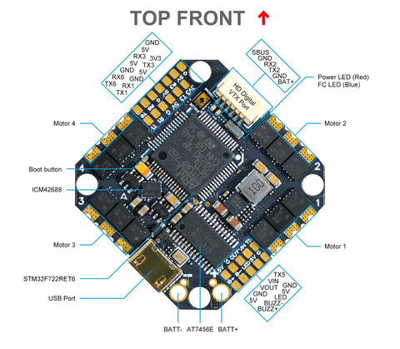

The below picture is the bottom front of the F722 35A AIO Brushless FC. (Both V1 and V2 boards have the same solder pad and connector ports.)

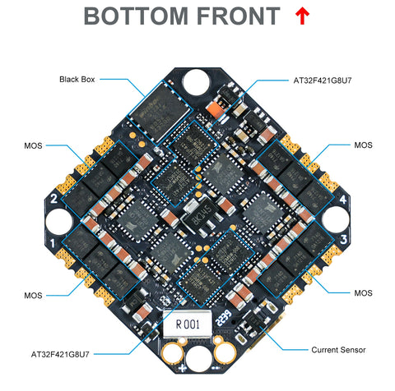

There are 2 LEDs on the bottom of the board to indicate the status, including the FC LED (Blue) and FC Power LED (Red). The LED status for V1 and V2 boards are the same.

|  |  |  |
| --- | --- | --- |
| **LED** | **Status** | **Description** |
| FC LED (Blue) | Solid | Armed |
| FC LED (Blue) | Extinguished | Disarmed |
| Power LED (Red) | Solid | Power on |

**How to Connect the External RX&VTX**

To connect the external RX&VTX, please refer to the below diagram. F722 35A AIO V1 and V2 boards have the same soldering pad and connecting ports.

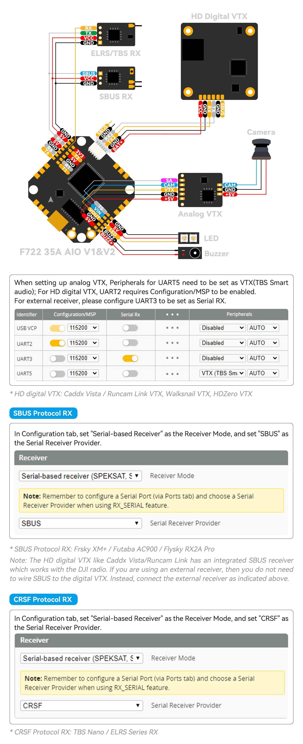

**Recommended Parts**

* BNF: highly recommend for [X-Knight 5"](https://betafpv.com/collections/toothpick-quad/products/x-knight-5-toothpick-quad-hd-digital-vtx), [Pavo360](https://betafpv.com/products/pavo360-fpv-quadcopter), [Pavo30](https://betafpv.com/collections/betafpv-naked-camera-series/products/pavo30-whoop-quadcopter)
* Battery: 4-6S Battery, [BETAFPV 850mAh 4SBattery](https://betafpv.com/collections/4s-battery/products/850mah-4s-75c-lipo-battery-2pcs) [450mAh 4S Battery](https://betafpv.com/collections/4s-battery/products/450mah-4s-75c-lipo-battery)
* VTX: [BETAFPV A03 400mW 5.8G VTX](https://betafpv.com/collections/camera-vtx-1/products/a03-400mw-5-8g-vtx)
* Motor: [1805 1550KV brushless motor](https://betafpv.com/collections/brushless-motors/products/1805-brushless-motors?nopreview), [2004 Brushless Motors](https://betafpv.com/products/2004-brushless-motors), [1606 Brushless Motor](https://betafpv.com/collections/brushless-motors/products/1606-brushless-motors), [1506 Brushless Motor](https://betafpv.com/collections/brushless-motors/products/1506-3000kv-brushless-motors), [2204 Brushless Motors](https://betafpv.com/collections/brushless-motors/products/2204-brushless-motors), [2306 Brushless Motors](https://betafpv.com/collections/brushless-motors/products/snow-2306-brushless-motors)
* Compatible Propellers: [Gemfan 5125 3-Blade props](https://betafpv.com/collections/propellers/products/gemfan-5125-3-blade-propellers-5mm-1-5mm-shaft" \o "Gemfan 5125 3-Blad props" \t "_blank), [BETAFPV 4-5 inch props](https://betafpv.com/collections/4-inch-propellers)
* Frame: 3-3.5 inch frame, 4-5 inch Frame, highly recommend for [TWIG ET5 5'' Toothpick Frame](https://betafpv.com/collections/carbon-fiber-frame/products/twig-et5-toothpick-frame), [X-knight 5'' frame](https://betafpv.com/collections/carbon-fiber-frame/products/x-knight-4inch-fpv-racing-carbon-fiber-frame-kit), [X-Knight 360 Carbon Fiber Frame Kit](https://betafpv.com/collections/carbon-fiber-frame/products/x-knight-360-carbon-fiber-frame-kit), and [Pavo360 Frame Kit](https://betafpv.com/collections/brushless-frame/products/pavo360-frame-kit), [Pavo30 Pro Frame Kit](https://betafpv.com/collections/brushless-frame/products/pavo30-pro-frame-kit)

**FAQ**

* [Download the FC firmware and CLI dump file for F722 ICM42688 Gyro (V2 BLHeli\_32).](https://support.betafpv.com/hc/en-us/articles/14499219109273-CLI-for-Toothpick-F722-AIO-35A-Brushless-Flight-Controller-32-V2-)
* [Download the FC firmware and CLI dump file for F722 ICM42688 Gyro (V1 BLHeli\_S)](https://support.betafpv.com/hc/en-us/articles/11709633442329-CLI-for-Toothpick-F722-2-6S-AIO-Brushless-Flight-Controller-35A-ICM42688-).
* [Download the FC firmware and CLI dump file for F722 BMI270 Gyro (V1 BLHeli\_S).](https://support.betafpv.com/hc/en-us/articles/6673278865561-CLI-for-Toothpick-F722-2-6S-AIO-Brushless-Flight-Controller-35A-BMI270-)

**Package**

* 1 \* F722 35A AIO Brushless Flight Controller (V1 or V2)
* 1 \* Cable Pigtail (XT60)
* 1 \* Capacitance
* 1 \* 6-Pin Connector for HD Digital VTX
* 4 \* M2x10mm Screws
* 8 \* M2 Nuts